Online Bank Management

Done By:

* MD NAFIJUL HOQ - 20-42366-1

The table description and the following table’s constraints screenshot is given below:

1.

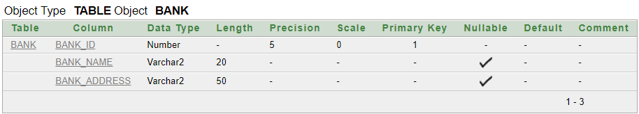



2.

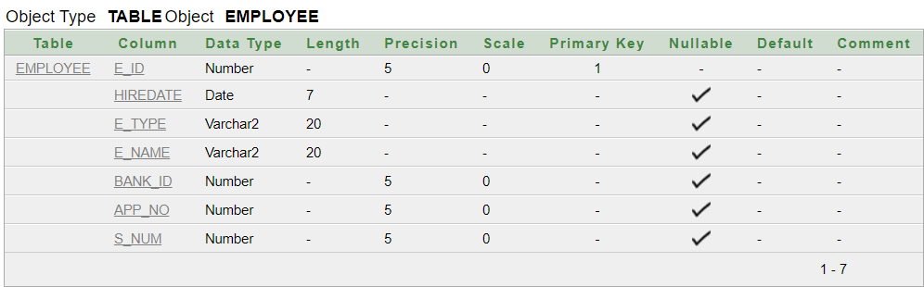

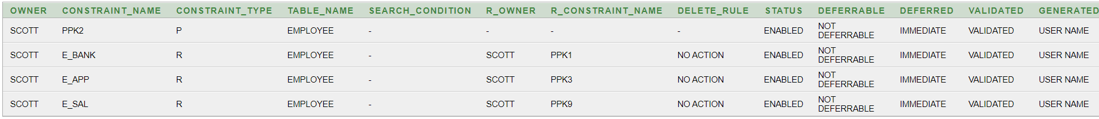

3.

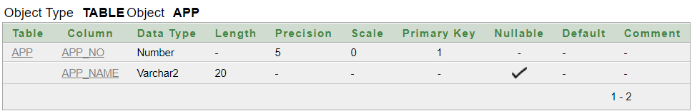



4.

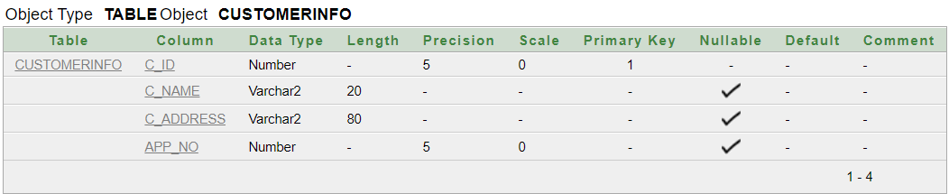



5.

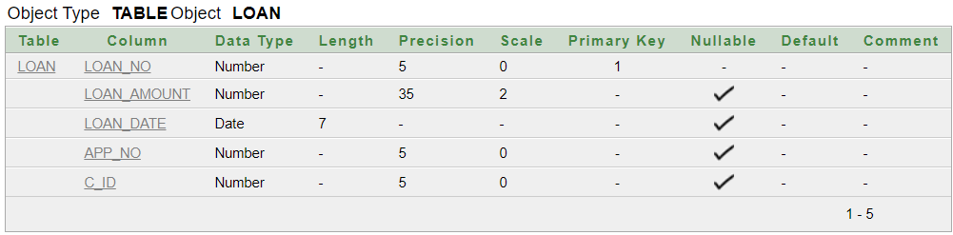

Here constraint ‘checkingamount’ will check if the loan amount is greater than 1000 or not.

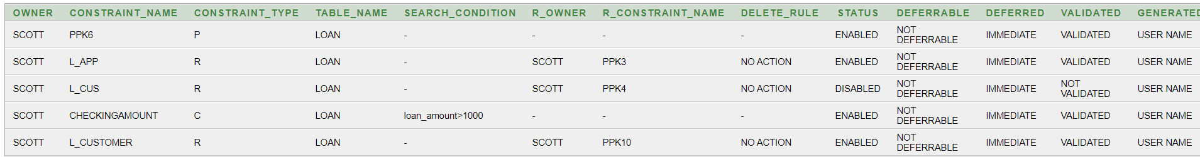

6.

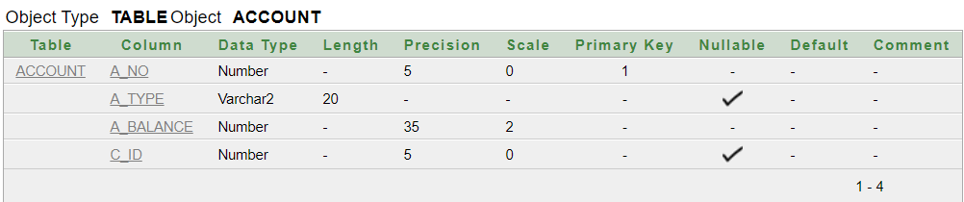

Here constraint “sys_c004710” is added to prevent null values.

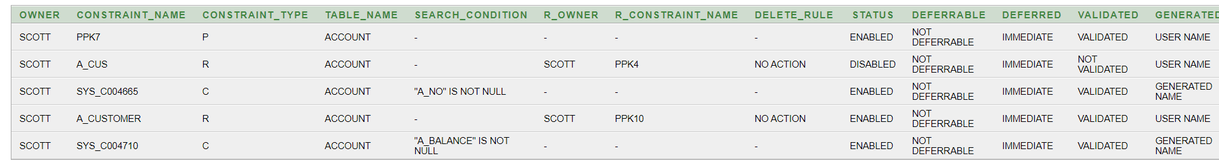

7.

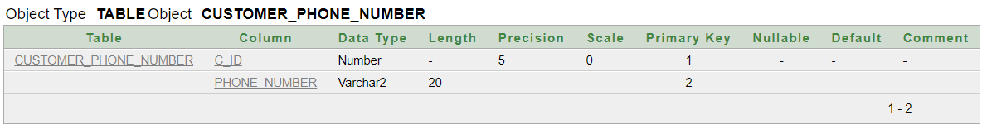

Here constraint “addingunique” will make sure every value is unique.



8.

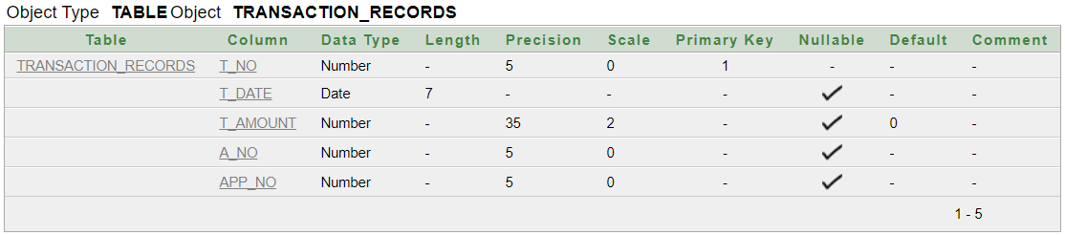

Here t_amount’s default value is set to 0.



9.

